**AMERICAN INTERNATIONAL UNIVERSITY–BANGLADESH (AIUB)**

**FACULTY OF SCIENCE & TECHNOLOGY**

**DIGITAL LOGIC AND CIRCUITS LAB**

**Summer 2022-2023**

Section: F

Group Number: 02

**EXPERIMENT NO. 9**

**NAME OF THE EXPERIMENT**

*Design and implementation of multivibrators using Timer IC*

**Supervised By**

SHAHRIYAR MASUD RIZVI

Faculty of Engineering, AIUB

**Submitted By**:

|  |  |
| --- | --- |
| **Name of the Student** | **ID Number** |
| 1. NOKIBUL ARFIN SIAM | 21-44793-1 |
| 1. AHNAF AHMED | 20-42173-1 |
| 1. SAIFUL ISLAM | 20-42585-1 |
| 1. MAHADI HASAN | 19-39711-1 |
| 1. SHEIKH FAHIM FUAD | 21-44721-1 |

**Introduction:**

The name of the timer comes from the three 5 kΩ resistors which are embedded in it [1]. This IC gives precise time at the output which is must in the time related circuits. One of its basic operations is to produce clock pulses with predefined frequency as an astable multivibrator. Another operation is to work like a stop watch which is done in monostable mode. We will see these two operations in this experiment. The following figure is the layout of the 555 Timer IC as which allows us to focus on the functions of the circuit.

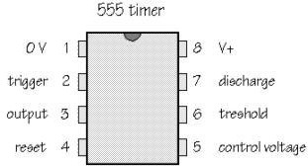

**Figure-1:** Pin configuration of the 555 timer IC.

**Theory and Methodology:**

**Astable multivibrator:** Astable multivibrator, in which the circuit is not stable in either state; it continually switches from one state to the other. It is also called a free running sinusoidal oscillator. An astable multivibrator is simply and oscillator. The astable multivibrator generates a continuous stream of rectangular off-on pulses that switch between two voltage levels. The frequency of the pulses and their duty cycle are dependent upon the RC network values. Astable multivibrators are used in the applications like pulse position modulation, frequency modulation, etc.

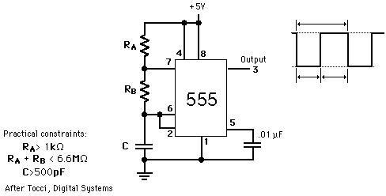

**Figure-2:** Circuit diagram for astable multivibrator.

**One shot multivibrator:** In the one-shot mode, the 555 acts like a monostable multivibrator. A monostable is said to have a single stable state--that is the off state. Whenever it is triggered by an input pulse, the monostable switches to its temporary state. It remains in that state for a period of time determined by an RC network. It then returns to its stable state. In other words, the monostable circuit generates a single pulse of fixed time duration each time it receives and input trigger pulse. It is also used to generate delays. When multiple one-shots are cascaded, a variety of sequential timing pulses can be generated. Those pulses will allow you to time and sequence a number of related operations. Pulse width of the output is given by T= 1.1 RC (in seconds)

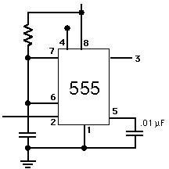

**Figure-3:** Circuit diagram for monostable multivibrator

**Apparatus:**

|  |  |
| --- | --- |
| 1. Resistors 1kΩ | 1[pcs] |
| 1. Resistors 1MΩ | 1[pcs] |
| 1. Capacitor 0.01uF | 1[pcs] |
| 1. Capacitor 10uF | 1[pcs] |
| 1. 555 Timer IC | 1[pcs] |

**Calculation:**

***Astable Multivibrator:***

RA = 1 KΩ = $1×{10}^{3}$ Ω

RB = 1 MΩ =

C1 = 10 µF = F

TH = 0.7 * (RA + RB) * C1 = 0.7 * (Ω + ) * F = 7.007 S

TL = 0.7 * RB * C1 = 0.7 * * 10F = 7 S

T = TH + TL = (7.007 + 7) = 14.007 S

F = 1/T = 1/14.007 = 71 mHz

***Monostable Multivibrator:***

R1 = 1MΩ =

C1 = 10 µF =

tW = 1.1 * R1 * C1 = 1.1 * * F = 11 S

**Hardware Implementation**

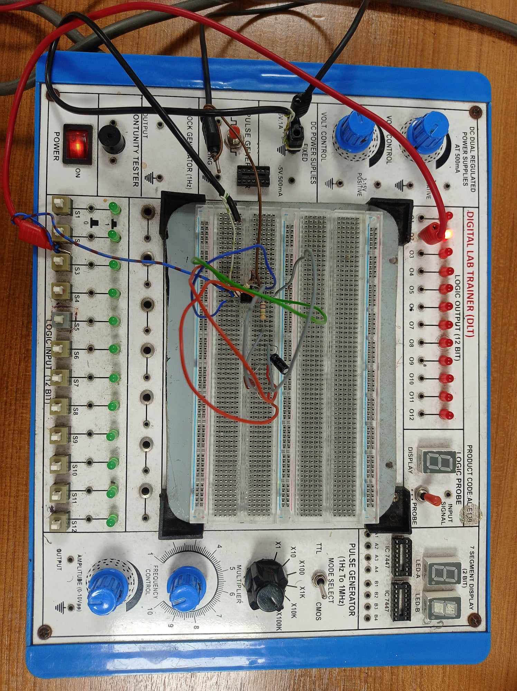

Astable multivibrator

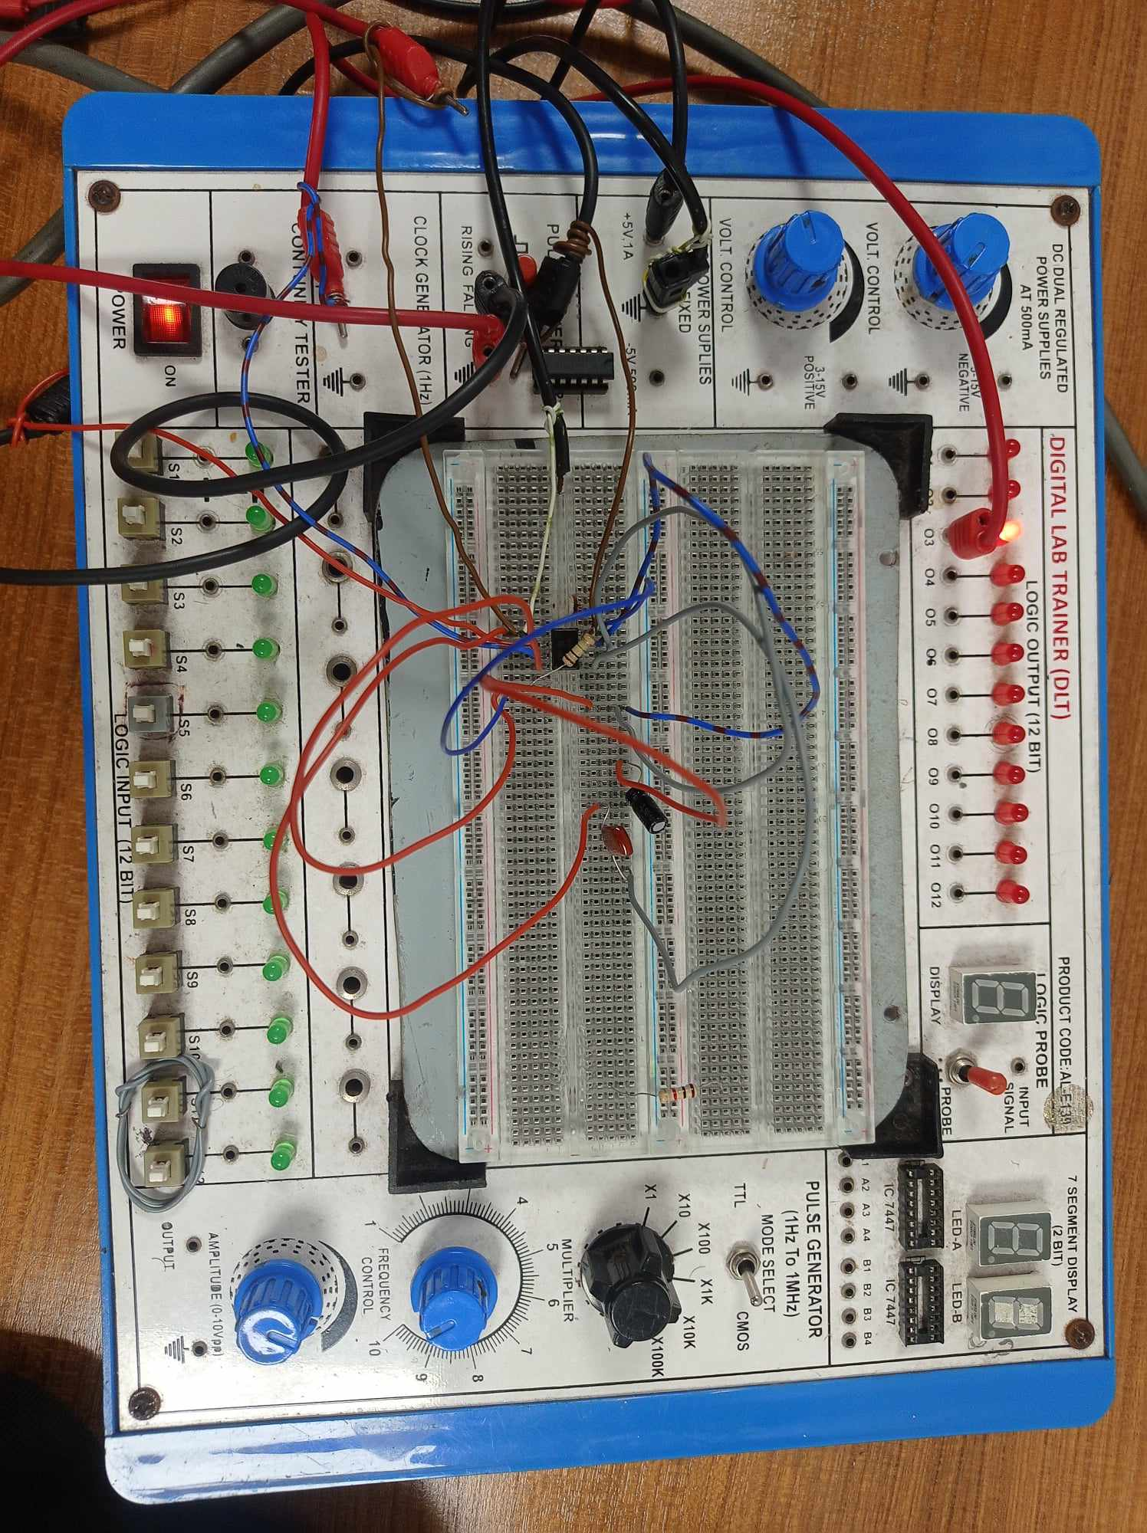

Monostable multivibrator

**Simulation:**

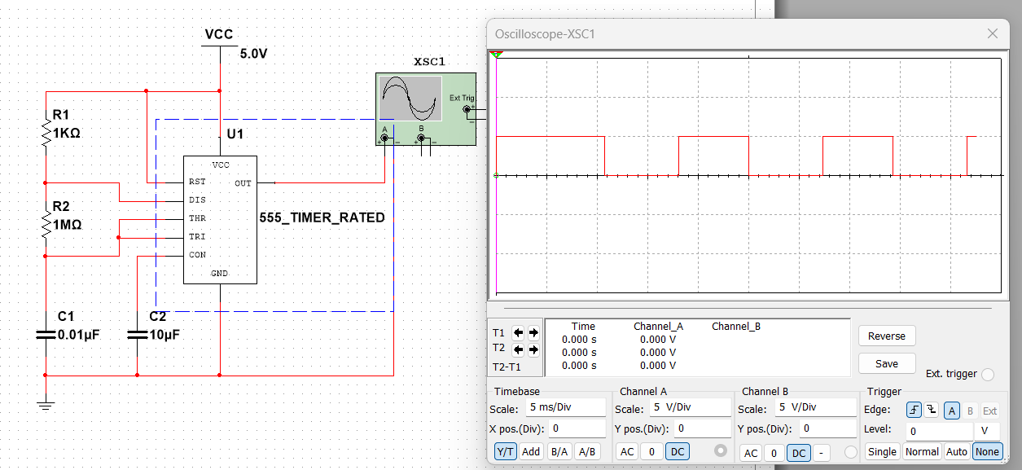

Astable multivibrator

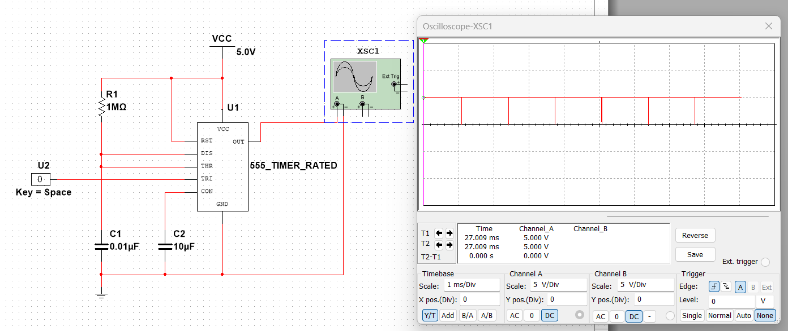

Monostable multivibrator

**Results:** The Simulation results matched all of our theoretical calculation data.

Astable Multivibrator:

|  |  |  |  |
| --- | --- | --- | --- |
|  | TH | TL | T |
| Calculated value | 7.007 S | 7 S | 14.007 S |
| Exp. value | 6.67 S | 6.46 S | 13.13 S |

Monostable Multivibrator:

|  |  |
| --- | --- |
|  | tW |
| Calculated value | 11 S |
| Exp. value | 11.5 S |

**Discussion:**

The primary goals of this experiment were to gain a practical understanding of the Astable multivibrator and its implementation using a 555 timer. Initially, we delved into the fundamental theory behind the Astable multivibrator utilizing the 555 timer. Subsequently, we constructed two circuits: one for an astable and another for a monostable multivibrator. We then observed the outcomes of these two operations. To implement these circuits and comparing the resulting outputs with our calculated expectations. Although a minor deviation was detected in the output, its impact was insignificant.

**Reference:**

1. Boylestad, Robert L., and Louis Nashelsky. *Electronic Devices And Circuit Theory*, 2006,

Pearson Prentice Hall.

2. Thomas L. Floyd, *Digital Fundamentals*, 9th Edition, 2006, Prentice Hall.